**St Peters Preschool Information Session**

Wednesday 17th May

5pm to 6.15pm

At St Peters Preschool

Join the Educators of St Peters Preschool in a presentation and discussion about…

* Tips for supporting Childrens Behaviour
* How climbing, jumping and risky play prepares children for reading and writing.

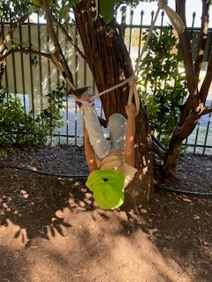

This is a child free event.

RSVP Monday 15th of May

Please note that the topics were the most popular from our recent Survey Monkey questionnaire.